Offer

M/S. SK GLOBAL IMPEX
Delhi (India)

Kind Attn: - Mr. Kamal Batra

Sub: Techno commercial offer for Powder Coating Plant & ETP plant with water recycling.
Dear Sir,

Thank you for the kind courtesy extended to your visit to our place regarding your requirement for Powder Coating & ETP Plant at your works.

Enclosed Please find detailed Techno commercial offer for the same.

Our Offer consists of:
- Data
- Technical Specifications
- System Description
- Price Summary & Scope Of Supply
- Commercial Terms & Conditions
- Exclusions from our scope of supply

Kindly go through the same & revert your valuable comments.

Look forward to your valuable Order at the earliest.

Yours faithfully,
For Value Added Coating Solution Pvt. Ltd.

Harish Sharma
(Director)

VACSPL’s Proposal

For

SK GLOBAL IMPEX.

POWDER COATING & ETP PLANT
04 May 2025

Value Added Coating Solution Pvt. Ltd
H.O.: 515, Devika Tower, Chander Nagar,
Ghaziabad, U.P. – 201010, (India).

Proprietary Notice

The information and data furnished in this document shall not be disclosed outside M/s. SK GLOBAL IMPEX shall not be duplicated, used or disclosed in whole or part for any purpose other than to evaluate this proposal: provided, that if a contract is awarded to this offer or as a result of or in connection with the submission of this information / data, M/s Value Added Coating Solution Pvt. Ltd. shall have the right to duplicate, use or disclose the information / data to the extent provided in the contract. This restriction does not limit M/s. Value Added Coating Solution Pvt. Ltd. right to use information contained in the proposal if it is obtained from another public source without restriction.

Table of Contents
- Value addition by VACSPL
- Plant description
- Data
- System Description & Assumptions
- Technical Specifications
- Scope of supply and price summary
- Commercial terms & Condition.

- VALUE ADDITION WITH Value Added coating solution Pvt. Ltd

- Leader & Legend - VACSPL pioneered the powder coating technology in India .

- Constant efforts towards developing better technology in surface coating at our R & D base.

- Easy availability of spares ensures continuous production.

- Prompt service from our sales and service offices at Ghaziabad,Gurgoan,Noida, Rudarpur & Hossur who are technically competent to handle any eventuality.

- PLANT DESCRIPTION

INDEX

DESCRIPTION Page No.1-30

- Data provided by you & Assumptions & System
Description

- Technical Specifications

Powder Curing Oven
Overhead Conveyor
Powder Spray Booth & Recovery System
Gema Powder Coating & Powder Management System
Pre-Treatment Line
Hoist for PT Line
Water Drying Oven
Effluent Treatment Plant
RO Plant For Raw Water
DM Plant For Raw Water
UF RO Plant For treated water recycling
Compressor for Pneumatic air

- Makes of Important Items & Prerequisites at site

- Price Summary & Scope of Supply

- Exclusions from VACSPL’s Scope of Supply

- Commercial Terms & Conditions

DATA PROVIDED BY YOU:
Article | Aluminum Profiles
Space Requirement(mm) | 81000X23000X7000
Maximum Component size(mm) | 6500X200X200
Conveyor speed | 2.5 Meter/min
Heat source | LPG/PNG/HSD
Number of components Per Hour | 100
Weight Per Profile(6500X200X200) | 10 Kg
Profiles Per Hanger | 5 Nos
Profiles Weight Per Hanger | 50 Kg
Hangers Per Hour Output | 20 Nos
Production Per Hour | 1000 Kg
Production in 12 Hour Shift | 12000 kg/Day
Production in a Month(25 days working) | 300 MT

SYSTEM DESCRIPTION AND ASSUMTIONS:

Powder Coating Plant

As discussed, we have offered powder coating plant with 2.5 Mtr/min conveyor speed

The Powder Coating System consists of Pre-treatment Tanks, Material Lifting Hoist,, Powder Spray booth, Powder spraying Guns, Conveyorised Powder Coating Curing Oven( Straight type) .
Articles will be loaded Horizontally i.e. 6500 mm along with conveyor,200 mm across the conveyor & 1500 mm height. Article pitch would be 500 mm. Maximum article size which can pass through oven cutouts would be 6500mm x300mm x 1400 mm (L xW x H).
After loading on conveyor the article will first pass through the Powder Coating Booth which is automatic zone with manual Back-to-Back type.
Articles will be powder coated automatic guns & touch up manually inside powder coating booth by two operators standing diagonally opposite positions.
After that articles will pass continuously through powder curing oven for 20-22 min at 200-220⁰ Celsius.
The oven offered is Straight type with Heat Exchanger & LPG fired burner.

After cooling the cured articles will be unloaded at unloading point.

POWDER

COATING

PLANT

@ 2.5 Mtr/Min maximum Conveyor speed

Technical Specifications

I) Powder Curing Oven-

Type : Gas Fired-Straight Type

Blower Motor Rating : 20 HP – 2 Nos

Air Seal Motor Rating : 5 HP- 2 Nos

Heat Source : LPG/PNG/HSD

Insulation : 150 mm thick Rock wool

Insulation Density : 96 Kilogram/Cubic Meter

Max. Temperature : 250 ⁰ C.

Blower Capacity : 24000 CMH- 2 Nos

Heat Load Capacity : 4,30,000 Kilo Calory

Burner Capacity : Max Gas-500(Ecoflame Italy)

Heat Circulation : Ducts & Adjustable Louvers

Air Seals : Entry & Exit

Dead Zone : 1500mm long (Entry & Exit)

Entry/Exit Envelope Size : 2300mmX800mm

Material Of Construction : Male-Female Cassette type Construction.
The Cassettes are made out of CRMS 1.2
mm thick Sheets Suitable supporting
Structure is provided.
For sealing gaps Silicon Sealant is used to avoid heat leakages.

Heat Exchanger : 3 pass Shell & Tube type heat exchanger is provided. The shell is constructed out of SS 304 and Tubes are SS 304 and MS
Erw.

Hot Air Circulation : For uniform heating inside the oven
Centrifugal blower is used. The ducting is provided with Air Directional Blinds.

II) Overhead Conveyor -

Type : Over-Head (5T Enclosed)
Conveyor Length : 150/160 mtr
Conveyor Height : 3300 mm
Conveyor speed : 2.5 meter/min
Chain Pitch : 100 mm
Hanging Pitch : In Multiples of 200 mm
Weight Capacity : 30 Kg Per Hook
Bend Radius : 1500mm
Drive : Straight
TKP Unit : Screw Type
Lubrication Unit : Provided
Control Panel : For variable speed
Conveyor Supports : Provided

III) POLLUTION FREE POWDER SPRAY BOOTH & RECOVERY SYSTEM-GEMA(Switzerland)

Gema Group
Pioneer in electrostatic powder coating
Gema is a company with a long history. Founded in Switzerland in 1897 by Messrs. Gehrig and Mannhart (hence the origin of the name) Gema started as metal fabricator and later specialized in metal ceilings.
In the 1960’ years Gema started to experiment with the idea - at that time revolutionary - of electrostatic powder coating and produced the very first powder gun on the market. Although initially developed for its own use, the technology was so interesting and efficient that it was decided to start selling powder guns: the Gema electrostatic division was born!
Gema became a stand-alone company in 1982 with the spin-off of the electrostatic division.
Since 2012 Gema is part of Graco (www.graco.com), an internationally leading supplier of management solutions for fluids and coatings in both industrial and commercial applications. Part of our division are also SAT (www.sataluminium.com), market leader in vertical finishing systems for aluminum extrusions, and Hildebrand Technology (www.hildebrand-technology.com), our experts in static control solutions.
Always one step ahead
After starting first, Gema has kept its leadership position in powder coating for more than 50 years thanks to a strong focus on R&D and creativity. Over the years Gema launched so many famous innovations and unique designs, like the first gun with integrated high voltage generator, the MFR filter-belt booth, the Magic Cylinder round booth design, the SuperCorona free ions collector, the first OptiSelect manual gun with integrated remote control, the MagicCenter powder kitchen with automated color change, the EquiFlow booth airflow design, the Smart-Inline-Technology of our dense phase pumps, the contour detection laser scanner for automatic application, the new All-In-One gun control units…
Today Gema can count on the largest patents portfolio in the market and offers a broad variety of products and solutions, from manual coatings to the most sophisticated industry 4.0 automations.
A strong worldwide presence
Gema’s worldwide headquarters are in St. Gallen, Switzerland; here our team works every day to develop our newest technologies and to make sure that our products are manufactured in perfect quality and punctually delivered everywhere in the world.
Our distribution network includes a combination of Gema business units and independent distributors in more than 60 countries worldwide, offering sales and service support to maintain the Gema equipment in perfect shape for many years after the first installation.

Application experts in every market
Architectural elements, home appliances, automotive components, metallic furniture… everywhere the most famous brands rely on our expertise for their powder coating projects.
Our state-of-the-art coating laboratories are available in Europe, America and Asia for the most complex coating trials. Here our customers can test our advanced technologies and determine the most effective equipment configuration to achieve the best application quality.

Gema Powder Coating System, consisting of;

Item 1.00 Gema Stainless Steel Booth Type Magic Plus
with Mono Cyclone + After Filter

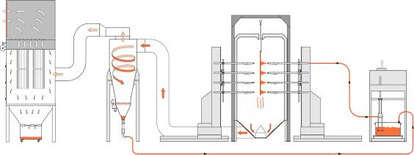

Technical Data

1.) Work piece data:
Type of Object: Aluminum Profiles
Max. Height 1400 [mm]
Max. Width 200 [mm]
Max. Length 6500 [mm]

2.) Max.Coating Envelop Size

Max. Height 1600 [mm]
Max. Width 500/1 [mm]

3.) Production data:
Speed of Conveyor: 2.5 [m/min]

4.) Application data:
Multi Color System
Type of powder organic powders

5.) Connection values:
Compressed air data
Max. input pressure 10 [bar]
Min. input pressure 6 [bar]
Max. permissible water vapor content 1.3 [g/m³]
Max. permissible oil vapor content 0.1 [mg/m³]
Max. Compressed air consumption 150 [Nm³/h]
(Compressed air connections Required at 8 to 10 locations)

Electrical connection data:
Single phase voltage 240 [V]
Three phase voltage 3 x 415 [V+N+PE]
Frequency 50 [Hz]
Voltage tolerance ± 10 [%]
Type of protection class IP54
Max. Power consumption 50 [kW]
(Power Supply with Proper Earthing Required at 2 locations)

6.) Operating conditions:
Ambient air temperature range +10 to +40 [°C]
Work piece temperature range +10 to +50 [°C]
Air flow /Thermal current near the booth < 0.1 [m/s]
For approved coating powders only!

Item 1.00 1 Gema Color Change Stainless Steel Booth: Magic Plus
(Manufactured locally based on Gema Design & Specification)

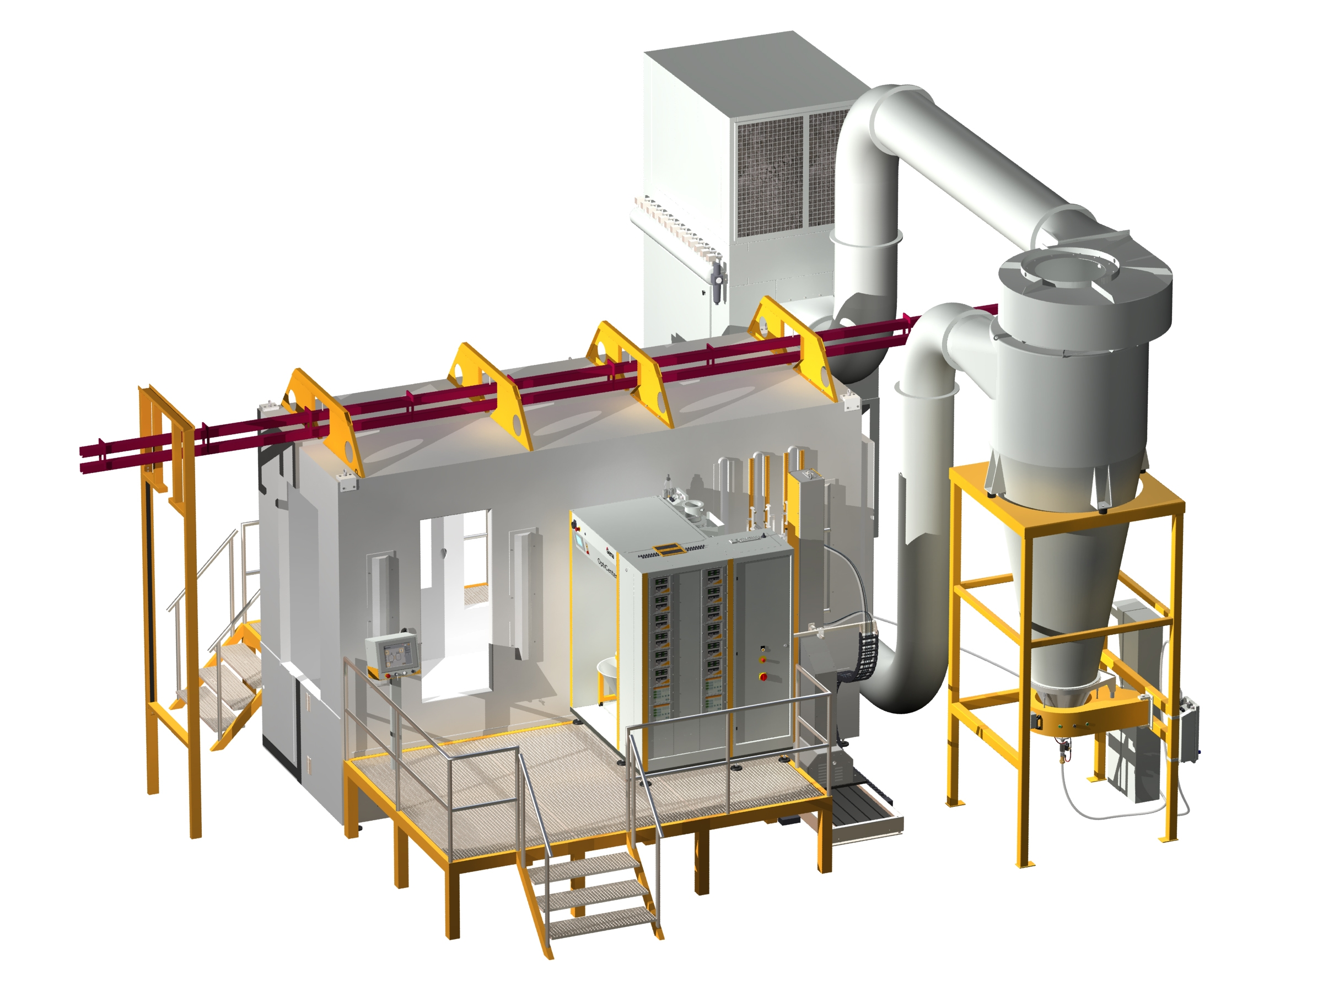

Sample of a MagicPlus system

Dimension of booth: Approximate
(without roof frame work) internal external
Length 4972mm 5000 [mm]
Width 1’800 1500 [mm]
Height 3600 3300 [mm]

Booth openings
Height 1600 [mm]
Width 500 [mm]

Item 1.01 1 Magic Plus Stainless Steel booth, quality design,

consisting of:
- Accessible base, with hinged air channel and adapter for air duct
- Upper structure, self-supporting, with two object openings, one with a pair of doors, 4 lighting in the walls, roof with frame work, holding the two walls.
- Accessible base, with hinged air channel and adapter for air duct
- Upper structure, self-supporting, with two object openings, one with a pair of swing doors, 4 lighting in the walls, roof with frame work, holding the two walls.
- 2 manual gun operator opening

Item 1.02 1 Multicolor recovery system, consisting of
Mono cyclone, exhaust air volume
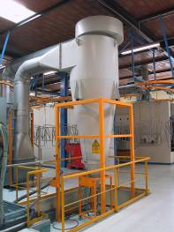

Sample Picture

Item 1.03 1 Filter, in combination with a mono cyclone,
exhaust air volume max.

consisting of:
- Filter box with fan and motor
- Filter cartridges and automatic filter cleaning system
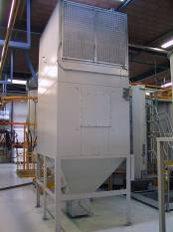
- waste powder container
- Sound level ≤ 80 [dB(A)]

Sample Picture

Item 1.04 1 Air duct between booth and mono cyclone, painted steel

Item 1.05 8 [m] Air duct between mono cyclone and after filter, made of
galvanized mild steel

IV) Powder Coating GUNS & Powder Management System- GEMA(Switzerland)

Technical Description

Project Specifications

Work piece data:
Type of Object: Aluminum Profiles
Max Height 1400 [mm]

Production data:
Speed of Conveyor: 2.50 [m/min]

Application data:
Powder Type: Organic Powder

The design of this solution is based on the experience we have gained from several successful projects with similar technical specifications.

Scope of Supply

Automatic Application Equipment
1 OptiFlex AS10 electrical cabinet (Made in India)
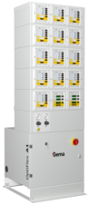
Freestanding base cabinet, equipped with pneumatic unit, including air filter/regulator and air connection sockets for control units
Modular upper structure designed to accommodate Gema master control , gun controls, reciprocator controls, powder hopper controls
Power supply
Standard: 3x400 VAC+N+PE / 50/60Hz
US Market: 100-120 V 60Hz

Technical data:
Width: 600 [mm]
Depth (incl. base): 300 (550) [mm]
Max height: 1'880 [mm]
10 OptiStar 4.0 CG20 gun control
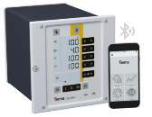
The new benchmark for gun controls
3 pre-set standard application programs and 250 user definable application programs - easy operation for beginners / powerful functions for the experts
PCC technology to optimize the electrostatic charging even for challenging powders
DVC technology grants the most precise and repeatable powder output settings
Powder output calibration function, allowing for identical powder output at identical settings for all guns of a powder coating line, irrespective of their individual powder hose length
Adjustment function to temporally change the powder output, without modifying the selected application program
Wear part monitoring by working hours counters for the main wear parts
Bluetooth connectivity to Gema E-App allowing device setup, application parameter adjustments and line data monitoring via mobile device
Key pad lock to prevent unintended user input
Diagnostics module and error code indication for easy trouble shooting
Rinsing mode to remove powder accumulations from the injector, powder hose and gun

8 OptiGun GA03 automatic gun
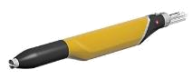
More powder on the parts - less in the recovery
Based on Gema corona charging technology
Integrated 100 kV high power cascade for unmatched first pass transfer efficiency
Equipped with high efficiency nozzle, ensuring highest quality application results
Wide selection of special nozzles available as option
Robust design, optimized for fast & reliable color change as well as low & easy maintenance
Designed for use of organic and metallic powders
2 OptiSelect GM04 manual gun
The manual gun for maximum coating performance
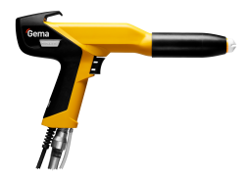
Based on Gema corona charging technology
Integrated 110 kV PowerBoost technology based cascade for unmatched first pass transfer efficiency
Equipped with high efficiency nozzle, ensuring highest quality application results
Wide selection of special nozzles available as option
On-gun remote control to adjust all coating parameters
Robust design, light weight and very ergonomic design
Optimized for fast & reliable color change as well as low & easy maintenance
Designed for use of organic and metallic powders
10 OptiFlow IG07 injector
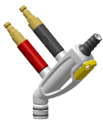
The first choice in injector technology for high performance powder conveying
Single-component Inline Cartridge Design and 135° open angle design reduces wear consumption, guarantees a long term consistent powder flow and enables even faster wear part exchange
Designed to work with Gema DVC Technology
All connections equipped with quick release couplings - Plug & Convey
Robust die-cast housing
Designed for mounting on fluidized powder hopper, includes suction tube
1 HF100 powder hopper (Made in India)
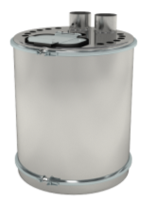
High quality fluidized bed, designed to accommodate up to 12 injectors
Opening for automatic powder supply and opening with lid for manual powder supply and inspection
Easy to clean stainless steel construction
Opening to accommodate level probe
Air mover

Technical data:
Diameter 24 mm
Height 600 mm
Capacity 100 l
1 Caster for HF powder hoppers

1 OptiAir CA12 powder hopper control
Ideal for optimal powder conditioning
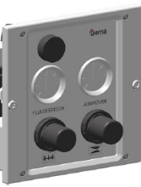
Manual pressure regulators and pressure gauges for fluidizing and air mover
Manual pre- fluidizing function to "loosen up" compacted powder.

Reciprocators and Automation Equipment
2 OptiMove CR08 reciprocator control unit
The most powerful and user-friendly reciprocator control
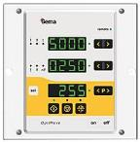
control unit for one Gema ZA reciprocator or XT axis
Clear interface for an intuitive operation
Stores and recalls reciprocator programs for an easier automated operation of the line. More reproducible coating results!
Different operating modes to meet every need:
oscillating mode, with up to 250 programs; each program consists of lower reverse point, upper reverse point and speed
positioning mode, with up to 250 programs; each program consists of end position and speed. Typical for horizontal XT axis
sequential mode, with up to 250 program steps; realize complex movement cycles, consisting of individual segments with different end positions and speeds
Installation in the OptiFlex AS cabinet

Technical data:
Positioning error < 5 [mm]

2 ZA10-18 Reciprocator
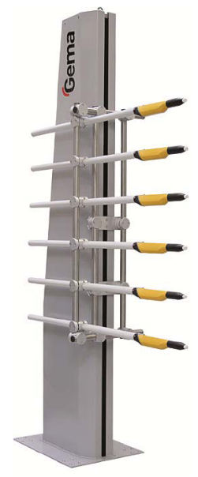
The easy solution for your automation needs
Reliable trouble-free operation with minimum maintenance costs
Smooth acceleration, ideal for the best coating results
Vertical carriage with plastic rollers and belt drive
Synchronous motor

Technical data:
Height 2760 [mm]
Width (base) 550 [mm]
Width (column) 250 [mm]
Depth 750 [mm]
Stroke 1800 [mm]
Speed 0.08 to 0.6 [m/s]
Acceleration 0.1 – 2.0 [m/s²]
Max load 25 [kg]
Power consumption 0.4 [kVA]
Max cable length to the CR control 20 [m]
2 Trolley for manual displacement of one reciprocator
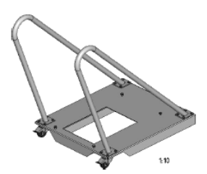
Base trolley
Rollers and locking clamps
Handles to move the reciprocator
4 Gun supports

Powder Management & Transfer Equipment
1 PS2 vibratory sieve(Made in India)
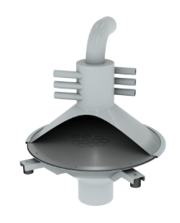
An easy and effective solution to improve your finishing quality
- Releases powder agglomerations and separates dirt particles
- Robust electrical vibrator
- Ergonomic and easy access for cleaning

Technical data
Screen diameter 420 [mm]
Mesh size 300 [µm]
Powder throughput up to 3 [kg/min]
depending from powder type

V) Pre-Treatment Line

Basis For Design

PRE-TREAT MENT PLANT 7-Tank Cold Process

******(Please Consult Chemical Supplier)
PROCESS

Sr.  No | Process | Time  Mins | Temperature  In⁰C | Overflow | No.of  Tanks
1 | Degrease | 10 | Ambient | Occasional | 1
2 | Rinse-1 | 1 | Ambient | Occasional | 1
3 | Rinse-2 | 1 | Ambient | Occasional | 1
4 | Desmutting | 2to3 | Ambient | Occasional | 1
5 | Rinse-3 | 1 | Ambient | Occasional
6 | Chromotizing | 2to3 | Ambient | Occasional | 1
7 | Rinse-4 | 1 | Ambient | Occasional | 1
8 | WDO-Water  DryingOven | 10-12 | @120DegC |  | 1

TANK SIZE | (LXWXH in mm) | 7100X1500X1800 (Approx..)
CAGESIZE | (LXWXH in mm) | 6600X1300X1400 (Approx..)
MATERIAL HANDLING- Double Hoist/EOT–Electric Overhead Crane– 2X1000kgs Motorised with Remote

Construction Of Tanks-By Value Added Team at Customer Site

Tanks for Pretreatment

- All 7 tanks are manufactured out of 2mmthick SS- 304 sheet

- Sheet with suitable stiffening of structural steel with Epoxy Painted will be provided with flanged outlet for drain over flow.

- All the tanks have 50mm slope at the bottom towards the drain.

- All the tanks have overflow chamber store move surface impurities.

5. All the tanks have flanged outlet for–Overflow, Drained water inlet
Electric Hoist -Double–Crane–2x1000Kgs with Remote +
TECHNICAL SPECIFICATION OF ELECTRIC WIRE ROPE HOIST

Make | : | Light Lift/Globe/Similar Brand
Type of EOT | : | Electric Wire Rope
Capacity (Ton) | : | 1.0x2 nos.
Design Standard | : | IS:3938
Class of Duty | : | Class II
Height of Lift (Mtr.) | : | 6.0
Hoisting Speed (MPM) | : | 6.0
Hoisting Motor (HP) | : | 3.0x 2
CT Speed (MPM) | : | 15.0
CT Motor (HP) | : | 0.33
Wire Rope | : | 6x36Construction (FMC) (8mmx2Falls)
Hook | : | Forged Hook ‘C’ Shank Type
Control | : | From Floor Through Pendant Push Button Station
Tested | : | The Hoists are Tested at125% Safe Working Load.
Control Panel | : | Schneider +L&T

Water Drying Oven-

Type : Gas Fired-Tank Type

Blower Motor Rating : 10 HP – 1 Nos

Oven Door : Motorised Lid Type

Heat Source : LPG/PNG/HSD

Insulation : 150 mm thick Rock wool

Insulation Density : 48 Kilogram/Cubic Meter

Max. Temperature : 150 ⁰ C.

Blower Capacity : 19,000 CMH- 1 Nos

Heat Load Capacity : 37,000 Kcal/hour

Burner Capacity : Max Gas-120(Ecoflame Italy)

MOC of Bottom of Oven : SS-304(2 mm Thickness)

Material Of Construction : Male-Female Cassette type Construction.
The Cassettes are made out of CRMS 1.2
mm thick Sheets Suitable supporting
Structure is provided.
For sealing gaps Silicon Sealant is used to avoid heat leakages.

Heat Exchanger : 3 pass Shell & Tube type heat exchanger is provided. The shell is constructed out of SS 304 and Tubes are SS 304 and MS
Erw.

Hot Air Circulation : For uniform heating inside the oven
Centrifugal blower is used. The ducting is provided with Air Directional Blinds.

Man Power Requirement at Customer Site
1.Un-Skilled Labour=8nos.
2.Skilled Labour= 2nos.
3.Supervisor=1no.

Walkway/ Platform

S.No. | Item | Description
1 | Walkway Size | 21.5 Mtr
2 | Qty. | 01Set
3 | MOC | Made of MS Section/Pipe /FRP Grit
4 | Operator  Movement | Walkway platform for operator movement along the  Entire span of PT Line Shall be provided
5 | Width | 1000mm
6 | Height | 750mm
7 | Access to  Platform | Through incline staircase
8 | Railing | Made of MS Pipe–throughout walkway
9 | Painting | Primer +Topcoat -Epoxy

AIR AGITATION (Optional /As per Chemical Supplier)

S.No. | Item | Description
1 | Blower Type | 1000CMH,RootBlower
2 | Motor Capacity | 5HP
3 | Distribution Pipeline &  Header | PVC1.5”/1”
4 | Holein Coils | From Side–PVC Pipe

VI) EFFLUENT TREATMENT PLANT(ETP)

Technical Comments

- Basis of Design
- Total flow – 5 kld

DETAILS OF THE UNIT OPERATIONS AND PROCESSES

PROPOSED TREATMENT SCHEME

As revealed by the data presented above, the main parameters which are considered for design of the proposed E.T.P. physical treatment. hence it is proposed to treat the effluents Physio-chemically.

DESIGN BASIS

The system will be based on Effluent water characteristics as under:
Flow: 10 m³ / day Operation Time-10 hr
Parameter | Inlet | Outlet
BOD | 700-750 mg/l,3day at 27 deg C | <30 mg/l,3day at 27 deg C
COD | 3000-3500 mg/l | <100 mg/l
TSS | 700-900 | <30 mg/l
PH | 5.5-12.0 | 6.5-8.0
Oil and Grease | 20 ppm | < 10 mg/liter
Temperature | 45 deg C | 25-30 deg C
Colour | Turbid | Colourless
Odour | Bad (Foul Smelling) | Odorless
Phosphate | 6.8 mg/liter | <2.0 mg/liter
Conductivity | 900-1000 us/cm | <120 us/cm

1.Collection Tank

This tank shall collect the waste water from the various tanks at various intervals to homogenize it completely.

2. Flash Mixer (Reaction Tank)

Here the effluents shall be mixed with certain chemicals for precipitation of the various metals and the proper mixing shall be provided by the twin Lobe Blower. There shall be 2 nos. of such reaction tanks one for dosing of Lime to raise the pH and another one for dosing the alum & polyelectrolyte.

3. Tube Settler

Here we are providing the Tube Settler along with the PVC media which will enhance the contact period and thereby the improved performance. The Tube settler will have a determined lope in the bottom to collect the suspended solids from the waste water. The sludge will be suited to the Sludge holding tank.

4. Dual media Filter
Here the treated water coming from the tube settler will be treated for the suspended impurity and colour removal.

5. Activated Carbon Filter

Here the water coming from the DMF will be treated for co lour removal, suspended impurity removal and the treated water shall be sent to the sewer.

6. Sludge Drying Beds

The sludge from the Tube settlers shall be dewatered on sand – gravel beds and will subsequently be dried by solar evaporation and the leachate will be drawn in to the collection tank. The dried sludge will be sent to the specified sites by the Statutory Authorities for disposal.
These limits are applicable to those which are either connected with sewers without terminal Sewage treatment plant or not connected to public sewers, for discharge into public sewers with terminal facilities, the general standards as notified under the
Environment (Protection) Act, 1986 shall be applicable.

Technical Specifications for Effluent Treatment Plant
 | ITEMS |  | BRIFE DESCRIPTION | SCOPE
1.0 | COLLECTION TANK |  |  | Client
 | Number off |  | One
 | Type |  | Civil Tank to receive effluent from process
 | Capacity |  | 20 cum
 | M.O.C |  | Civil
2.0 | INFLUENT LIFTING PUMPS |  |  | SWS
 | Number off | : | 2 No.
 | Capacity | : | 1.0-2.0 m3/hr at 50 m head
 | Type | : | Positive Displacement
 | M.O.C. |  | CI /PP
 | Make | : | KIRLOSKER
3.0 | REACTION TANK |  |  | SWS
 | Number off | : | One
 | Dimension | : | 1.0 M x 0.5 M x0 .6 M swd
 | Type |  | Air Agitated tank
 | Capacity | : | 0.126 cum
 | M.O.C. | : | MS with FRP lining
4.0 | CHEMICAL DOSING PUMP |  |  | NO PART
 | Number off |  | 3 Nos.
 | Capacity |  | 0-12 lph
 | Type |  | Positive displacement
 | Make |  | Aster/E-dose/eqv
5.0 | AIR BLOWER
 | Number off | : | One | 0
 | Type |  | Twin Lobe
 | Capacity |  | 1 H.P
 | Make |  | SMW/ Eqv.
6.0 | CLARIFIER |  |  | SWS
 | Number off | : | One
 | Type |  | Inclined at 60 Deg.
 | Dimensions |  | 1 M x 1 M x 2M (SWD)
 | M.O.C. | : | MS
 | Supports |  | Provided
7.0 | SLUDGE DRYING BED |  |  | Client scope
 | Numbers off | : | One
 | Capacity | : | 5000 Ltr.
 | M.O.C |  | Civil
8.0 | DOSING TANK |  |  | SWS
 | Number off | : | 3
 | Type |  | Under ground to receive the water from Tube Settler
 | Capacity |  | 15.0 cum
 | M.O.C. | : | HDPE/Eqv.
9.0 | FILTER FEED PUMP |  |  | SWS
 | Number off | : | 1
 | Capacity | : | 1 m3/hr at 50 m head
 | Type | : | Positive Displacement
 | M.O.C. |  | Pp
 | Make | : | Kirloskar PP PUMP
10.0 | DUAL MEDIA FILTER |  |  | SWS
 | Number off | : | One
 | Type | : | Down flow.
 | Dimension | : | 10 mm dia. x 54 mm hos.
 | Pressure (Working) | : | 4.0 kg/cm2.
 | M.O.C. | : | FRP/MS
11.0 | ACTIVATED CARBON FILTER
 | Number off | : | Two | SWS
 | Type | : | Down flow.
 | Dimension | : | 10 mm dia. x 54 mm hos.
 | Pressure (Working) | : | 4.0 kg/cm2.
 | M.O.C. | : | FRP/MS
12.0 | CONTROL PANEL WITH TIMER |  |  | 0
 | Number off |  | ONE LOT
 | Components |  | L&T Make
13.0 | PIPE &FITTING |  |  | SWS
 | Number off |  | One Lot
 | Make |  | Prince/eqv
 | M.O.C |  | UPVC
14.0 | SHED & PLATFORM FOR PLANT |  |  | Clients scope
 | Number off |  | One Lot
 | Make |  | MS and fiber sheet
14.0 | AIR LINE |  | 1 LOT | SWS

SCOPE OF SUPPLY
SR.NO. | ITEM DESCRIPTION |  | QTY.
01. | Flash mixer tank |  | 1 No.
02. | Tube Settler tank |  | 1 No..
03. | Interconnected piping & fittings (UPVC) |  | 1 Lot.
04. | Influent Lifting Pumps (Kilosker/Crompton/pp |  | 1 Nos.
05. | Twin Lobe Blowers |  | 1
06. | AUTOMATIC PLANT |  | 1
07. | Dosing Pumps |  | 3
08. | Dosing Tanks |  | 3
09. | Air Line |  | 1 lot
10. | Filter Feed Pump (Kilosker/Crompton/pp |  | 1 No.
11. | Dual Media Filter along with media |  | 1 No.
12. | Activated Carbon Filter along with media |  | 1No.
14. | Sludge pump |  | 1 No
15. | Flow meter |  | 1 No
16 | Ph meter |  | 1 No
17 | Air blower ½ hp |  | 1 No

DM Water Plant Capacity-1500LPG

S.No. | Particulars | Specification | Quantity
1. | RWP SS | CRI | 1Nos
2. | VESSEL16X65 | 2HELIX | 2Nos
3. | RESIN NIP |  | 150LTRS
4. | MPV25NBTMSOFTENER | INITIATIVE/UKL | 2 Nos
5. | RESIN225H |  | 150LTRS
6. | PH METER | ASTER | 1NOS
7. | SSSKID | 202 | 1Nos
8. | TANK | 100LITRE | 2NOS
9. | PIPE FITTING | UPVC | 1LOT

RO Water Plant
Capacity-1000LPH
Input TDS- 3000

S.No. | Particulars | Specification | Quantity
1. | PANEL | DIGITAL | 1Nos
2. | RWP | 1HP | 1NOS
3. | VESSEL 13×54 | HELIX | 2Nos
4. | MPV20NBTMFILTER | Initiative/UKL | 2Nos
5. | MEDIA | ALL SIZE | 250 Kg
6. | CARBON ID 800 |  | 25Kg
7. | HIGHPRESSUREPUMP | CRI 2-18 MVC | 1Nos
8. | MEMBRANEOUSING | 4080 UKL | 2Nos
9. | BIG BLUE WITH FILTER | 4.5X20” | 2Nos
10. | ROTAMETER | 2400LPH | 2Nos
11. | PRESSURE GAUGE(INPOTED) | 07KG/021KG | 4Nos
12. | MEMBRANE | 4040 DUPONT/LG | 4Nos
13. | PIPE&FITTING | 1.5”,¾”,1/2” | 1Lot
14. | SSSKID500LPH | SS202(25X25) | 1Nos
15. | ACRYLICSHEET |  | 1 Nos
16. | LPS | 1EACH | 1Nos
17. | DOSINGPUMP | /FC DOSE | 1Nos

UF RO Plant

S.No. | Particulars | Specification | Quantity
1. | MEMBREN | 4" | 2Nos
2. | BIGBLUE | 40*20 | 2Nos
3. | FILTER |  | 2Nos
4. | FEEDPUMP | 1HP | 1NOS
5. | BACKWASHPUMP | 1HP | 1NOS
6. | NRV |  | 2Nos
7. | SV |  | 2Nos
8. | ROTAMITER |  | 2Nos
9. | PRESSUREGAUZE |  | 2Nos
10. | SKIDSS304 |  | 1Nos
11. | PIPE&FITTINGUPVC | ASTRAL | 1LOT
12. | ELECTRICALPANAL AUTOMATICALLY |  | 1NOS
13. | SHEETOTHER |  | 1Lot

MAKES OF IMPORTANT COMPONENTS :
Motor Protection Relay |  |  | Siemens,Schenider, Make / Equivalent
Temperature Indicator |  |  | Selec & Devices / Equivalent
Voltmeter / Ammeter |  |  | Selec / equivalent
Contactors, Relays, HRC fuses |  |  | Siemens,Schnider
Motors |  |  | ABB,Siemens,Crompton/equivalent
SS/MS Sheet |  |  | Sail ,TATA,Jindal Nippon Denso/ equivalent
Blowers |  |  | Dust Tech / equivalent
Burner |  |  | Ecoflam/Rallo
Makes of items for conveyor :
Motor |  |  | Cromton/Siemens/equivalent
Gear Box |  |  | Kavitsu/Optima/ make
Variable Frequency Drive |  |  | Toshiba / Amron/standard Make
PRE – REQUISITE AT SITE :
Space Required |  |  | As per enclosed layout.
Electricity Required |  |  | Powder Coating line –  Gema Booth - 40.0 Hp  Oven - 40.0 HP  Double Hoist - 06.0 HP  WDO - 10.0 HP  Conveyor - 03.0 HP  Air Seal - 10 HP  Compressor - 25 HP  Gema Equipment -05.0 HP  ETP Equipment - 10.0 HP  ---------  Total 149 HP +/-10%
Earthing |  |  | For earthing suitable copper strip is required
Floor Required |  |  | Standard Industrial 6” thk concrete floor
Air Requirement  Powder Coating Equipment |  |  | 100 CFM / 6-7 kg pressure

PRICE SUMMERY & SCOPE OF SUPPLY

Sr. No. | Item Description | Qty
A | POWDER COATING PLANT
01. | Powder Curing Oven Tunnel Type – LPG Fired  (L-45000mm*W-1500mm*H-3375mm) | 1 Nos.
02. | Over Head Conyer For Material Handling-Enclosed type-5T | 150 Meter
03. | Water Drying Oven  (L-9200mm*W-2200mm*H-2200mm) | 1 Nos
04. | SS-304 Tanks for Pre-treatment  (L-7100mm*W-1500mm*H-1800mm) | 7 Nos
05. | Gema Powder spray Stainless Steel booth & Recovery System | 1 Set
06. | Gema Powder Spray Automatic & Manual Guns with Reciprocators & Powder Management System | 1 Set
07. | Air agitation line with blower | 1 Set
08. | Double Hoist Crane for Material Handling | 1 Nos
09. | Structure for Double Hoist Crane | As.Req.  .
10. | Structure for Material Handling Conyer | As.Req.
11. | Working Platform for Pre-Treatment Line | As.Req.
12. | SS Wire Cages | 4 Nos
13. | ETP Plant-5 KL | 1 Set
14. | UF RO Plant For Water Recycling | 1 Set
15. | RO Plant For Raw Water | 1 Set
16. | DM Plant For Raw Water | 1 Set
17. | Compressor For Pneumatic Air | 1 Set

Total Project (1 to17)-2,60,00,000/-(Rupees Two Crore Sixty Lakh only)

EXCLUSIONS FROM VACSPL’S SCOPE :

- Any kind of Civil Work & braking of walls etc. If required necessary drawings will be provided.

2. Electrical supply with proper isolators from mains up to the Control Panels at one or more points wherever required.

3. Compressed air supply of proper quality & quantity with regulators for various Equipments.

4. Fuel storage Tank / Supporting Structure / Fuel supply lines with filters & regulators up to the usage points.

- Article hanging jigs / hooks / hangers/Baskets/Flight Bar.

- Any type of consumables like powder / paint / P.T. chemical, Fuel / Booth
Additives etc. Which are required for trials & start up.

7. Unloading arrangement of material at site

- Dust/Foreign particles controlling / arresting system (i.e. Pressurized
Enclosure) in case of high quality painting / powder coating requirements.

9. Anything specifically not mentioned in our Scope Of Supply.

10. Utilities Services (air, water, fuel, power) etc.

11. All consumables

- Unskilled labor

- Plumbing External Wiring

COMMERCIAL TERMS AND CONDITIONS

- The price quoted is ex-works Greater Noida.

- Packing,Insurance & Freight will be extra.

- Payment Terms:

* 50% of basic order value as advance along with technically &
Commercially clear purchase order.
* 50% against Performa Invoice prior to dispatch on pro data basis.

4. Delivery will be within 60 Days from the date of receipt of your commercially and technically clear Purchase Order along with 50% advance.

5.Warranty: the equipments offered by us are warranty for 15
Calendar months from the date of dispatch or 12 calendar months from the date of commissioning which ever is earlier against any manufacturing defects.

6. Validity: our offer is valid only for 30 days from the date of this offer.

Value Added Coating Solution Pvt. Ltd.

Harish Sharma
(Director)

